**Temperature**

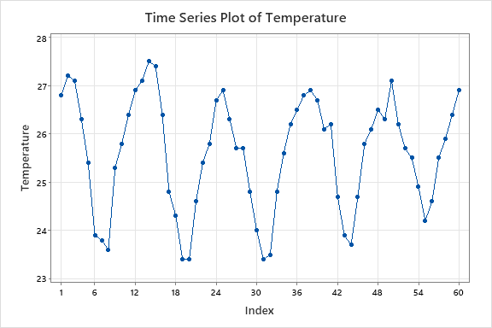**Time series plot**

There is a seasonal variation with trend.

**Autocorrelation Function: Temperature**

**Autocorrelations**

Lag ACF T LBQ

1 0.794075 6.15 39.76

2 0.406551 2.09 50.36

3 -0.052746 -0.25 50.54

4 -0.453396 -2.18 64.20

5 -0.708092 -3.16 98.11

6 -0.751445 -2.91 137.01

7 -0.617413 -2.11 163.76

8 -0.347182 -1.11 172.39

9 0.019509 0.06 172.41

10 0.377168 1.18 183.00

11 0.643064 1.96 214.39

12 0.740968 2.13 256.94

13 0.603444 1.62 285.76

14 0.279986 0.72 292.10

15 -0.091040 -0.23 292.79

16 -0.401132 -1.02 306.39

17 -0.567317 -1.42 334.24

18 -0.590920 -1.43 365.16

19 -0.458213 -1.07 384.21

20 -0.246989 -0.57 389.89

21 0.012885 0.03 389.90

22 0.265896 0.61 396.82

23 0.459297 1.04 418.03

24 0.519990 1.16 445.97

25 0.430034 0.94 465.63

26 0.216040 0.47 470.74

27 -0.056238 -0.12 471.09

28 -0.290342 -0.62 480.89

29 -0.413295 -0.88 501.39

30 -0.423772 -0.89 523.66

31 -0.327673 -0.68 537.43

32 -0.160164 -0.33 540.84

33 -0.007707 -0.02 540.85

34 0.170039 0.35 544.98

35 0.301060 0.62 558.47

36 0.344774 0.70 576.90

37 0.271435 0.55 588.81

38 0.132346 0.27 591.77

39 -0.045641 -0.09 592.14

40 -0.198579 -0.40 599.48

41 -0.256503 -0.51 612.36

42 -0.236031 -0.47 623.87

43 -0.148362 -0.30 628.69

44 -0.035886 -0.07 628.99

45 0.058887 0.12 629.85

46 0.115968 0.23 633.42

47 0.151614 0.30 640.00

48 0.148844 0.29 646.87

49 0.101999 0.20 650.39

50 0.021917 0.04 650.56

51 -0.050939 -0.10 651.64

52 -0.103203 -0.20 656.59

53 -0.101276 -0.20 662.04

54 -0.067317 -0.13 664.85

55 -0.007346 -0.01 664.89

56 0.029745 0.06 665.71

57 0.043232 0.09 668.03

58 0.036609 0.07 670.52

59 0.018786 0.04 671.84

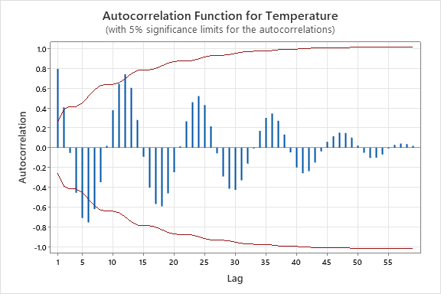

ACF cuts off at seasonal lag1. Here we can see a seasonal pattern. Therefore we have to do a seasonal difference.

**Autocorrelation Function: Temp2**

Autocorrelations

Lag ACF T LBQ

1 0.579912 4.02 17.17

2 0.434318 2.33 27.01

3 0.260519 1.26 30.63

4 0.240226 1.13 33.78

5 0.102530 0.47 34.37

6 0.079305 0.36 34.73

7 -0.015172 -0.07 34.74

8 -0.122642 -0.56 35.64

9 -0.054762 -0.25 35.83

10 -0.109636 -0.49 36.59

11 -0.246663 -1.10 40.53

12 -0.379890 -1.66 50.16

13 -0.278326 -1.15 55.47

14 -0.291931 -1.18 61.48

15 -0.154094 -0.60 63.21

16 -0.085232 -0.33 63.75

17 -0.033817 -0.13 63.84

18 -0.064370 -0.25 64.17

19 -0.048660 -0.19 64.37

20 -0.100460 -0.39 65.24

21 0.018294 0.07 65.27

22 0.009912 0.04 65.27

23 0.072370 0.28 65.78

24 0.066592 0.26 66.22

25 0.164641 0.63 69.05

26 0.173136 0.66 72.32

27 0.069807 0.26 72.88

28 0.029406 0.11 72.98

29 -0.118706 -0.45 74.76

30 -0.090018 -0.34 75.84

31 -0.080270 -0.30 76.75

32 -0.019975 -0.07 76.81

33 -0.136908 -0.51 79.81

34 -0.092651 -0.34 81.28

35 -0.099425 -0.37 83.11

36 -0.063437 -0.23 83.91

37 -0.083957 -0.31 85.45

38 -0.067977 -0.25 86.56

39 -0.058642 -0.22 87.47

40 -0.044041 -0.16 88.06

41 0.024038 0.09 88.25

42 0.036802 0.14 88.80

43 0.019725 0.07 88.98

44 0.024791 0.09 89.35

45 0.014744 0.05 89.53

46 0.013079 0.05 89.73

47 0.007514 0.03 89.87

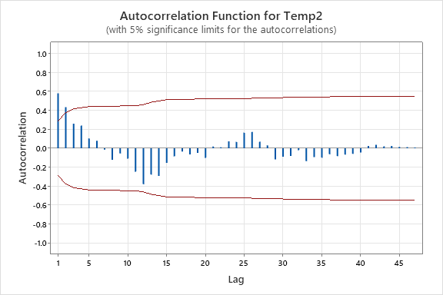

This is cuts off at non-seasonal lag 2.

**Partial Autocorrelation Function: Temp2**

Partial Autocorrelations

Lag PACF T

1 0.579912 4.02

2 0.147687 1.02

3 -0.061296 -0.42

4 0.104125 0.72

5 -0.113248 -0.78

6 0.017296 0.12

7 -0.074880 -0.52

8 -0.168174 -1.17

9 0.165876 1.15

10 -0.119344 -0.83

11 -0.260102 -1.80

12 -0.166371 -1.15

13 0.100166 0.69

14 -0.057211 -0.40

15 0.124717 0.86

16 0.074283 0.51

17 -0.000373 -0.00

18 -0.061589 -0.43

19 -0.150852 -1.05

20 -0.138382 -0.96

21 0.311853 2.16

22 -0.124230 -0.86

23 -0.006100 -0.04

24 0.025946 0.18

25 0.048037 0.33

26 0.011233 0.08

27 -0.190512 -1.32

28 0.021325 0.15

29 -0.070509 -0.49

30 -0.045347 -0.31

31 -0.045994 -0.32

32 0.007718 0.05

33 -0.015122 -0.10

34 -0.070125 -0.49

35 0.034993 0.24

36 0.070317 0.49

37 0.033966 0.24

38 -0.032655 -0.23

39 -0.059224 -0.41

40 -0.023051 -0.16

41 -0.078816 -0.55

42 -0.031941 -0.22

43 -0.004969 -0.03

44 0.059760 0.41

45 -0.011760 -0.08

46 -0.049328 -0.34

47 -0.078138 -0.54

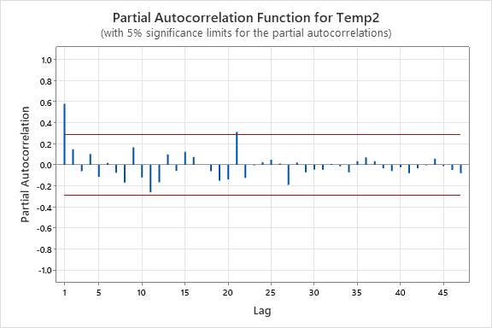

This is stationary at lag 2 at non-seasonal area.

Seasonal differenced

P=1

d=0

q=2

P=0

D=1

Q=0

S=12

SARIMA (1,0,2) (0,1,0)12

Trend differenced

**Autocorrelation Function: TempDifference**

**Autocorrelations**

**Lag ACF T LBQ**

**1 0.490873 3.77 14.95**

**2 0.216674 1.37 17.92**

**3 -0.109066 -0.67 18.68**

**4 -0.317628 -1.93 25.28**

**5 -0.490203 -2.81 41.30**

**6 -0.499581 -2.54 58.25**

**7 -0.381503 -1.76 68.32**

**8 -0.331856 -1.45 76.09**

**9 -0.016115 -0.07 76.11**

**10 0.184384 0.78 78.61**

**11 0.463182 1.94 94.69**

**12 0.613167 2.42 123.48**

**13 0.498308 1.80 142.91**

**14 0.143634 0.49 144.56**

**15 -0.078120 -0.27 145.06**

**16 -0.280921 -0.96 151.66**

**17 -0.370114 -1.24 163.40**

**18 -0.416554 -1.36 178.63**

**19 -0.272766 -0.86 185.33**

**20 -0.172276 -0.54 188.07**

**21 -0.037730 -0.12 188.20**

**22 0.135439 0.42 189.99**

**23 0.324101 1.01 200.49**

**24 0.407489 1.24 217.56**

**25 0.367240 1.09 231.84**

**26 0.204060 0.60 236.38**

**27 -0.068509 -0.20 236.91**

**28 -0.207850 -0.60 241.92**

**29 -0.265501 -0.76 250.38**

**30 -0.286809 -0.82 260.59**

**31 -0.228269 -0.64 267.29**

**32 -0.047687 -0.13 267.59**

**33 -0.098496 -0.28 268.93**

**34 0.076593 0.21 269.78**

**35 0.196629 0.55 275.57**

**36 0.309627 0.86 290.57**

**37 0.209585 0.58 297.76**

**38 0.128488 0.35 300.59**

**39 -0.010221 -0.03 300.61**

**40 -0.207448 -0.57 308.76**

**41 -0.151527 -0.41 313.35**

**42 -0.186380 -0.50 320.71**

**43 -0.079562 -0.21 322.13**

**44 -0.058353 -0.16 322.95**

**45 0.016323 0.04 323.01**

**46 0.041439 0.11 323.49**

**47 0.103922 0.28 326.73**

**48 0.133855 0.36 332.59**

**49 0.078888 0.21 334.83**

**50 0.040571 0.11 335.49**

**51 -0.014788 -0.04 335.59**

**52 -0.065882 -0.18 337.82**

**53 -0.070753 -0.19 340.82**

**54 -0.046658 -0.12 342.39**

**55 -0.017107 -0.05 342.65**

**56 -0.009383 -0.03 342.76**

**57 0.004757 0.01 342.80**

**58 0.006388 0.02 342.95**

